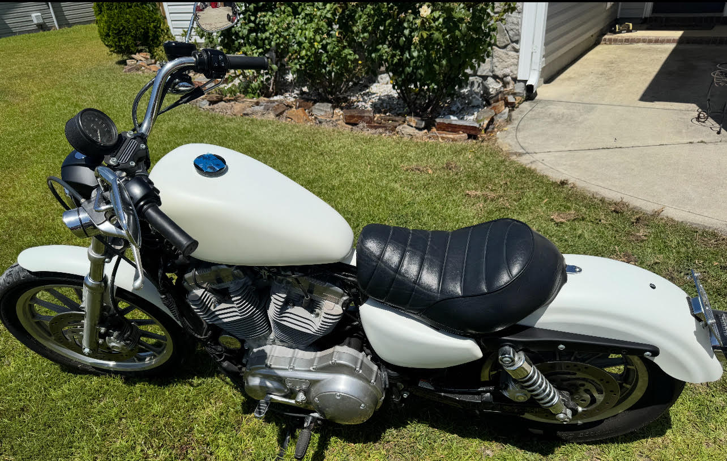
2009 883L For Sale
4311 miles
$4000 Contact Rob (Jacksonville NC)
910.988.1604
DOUBLE-CLICK LINK ABOVE FOR VIDEO

